2QA335 Global health in an interprofessional setting: A caring science perspective HT23 (fristående)
Respondents: 31
Answer Count: 15
Answer Frequency: 48,39 %

In my view, I have developed valuable expertise/skills during the course.
In my view, I have developed valuable expertise/skills during the course. Number of responses  to a very small extent 0 (0,0%)  to a small extent 0 (0,0%)  to some extent 4 (26,7%)  to a large extent 7 (46,7%)  to a very large extent 4 (26,7%)  Total 15 (100,0%) | 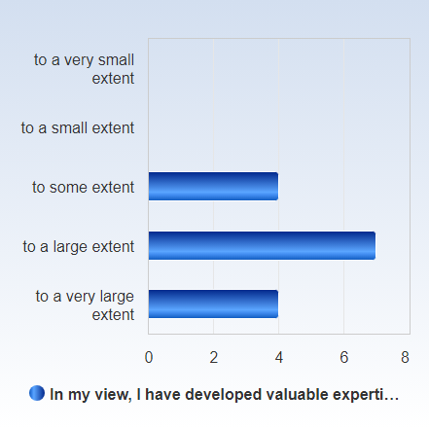

 | Mean | Standard Deviation | Coefficient of Variation | Min | Lower Quartile | Median | Upper Quartile | Max
In my view, I have developed valuable expertise/skills during the course. | 4,0 | 0,8 | 18,9 % | 3,0 | 3,5 | 4,0 | 4,5 | 5,0

In my view, I have achieved all the intended learning outcomes of the course.
In my view, I have achieved all the intended learning outcomes of the course. Number of responses  to a very small extent 0 (0,0%)  to a small extent 0 (0,0%)  to some extent 2 (13,3%)  to a large extent 7 (46,7%)  to a very large extent 6 (40,0%)  Total 15 (100,0%) | 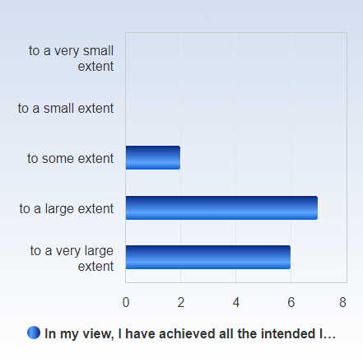

 | Mean | Standard Deviation | Coefficient of Variation | Min | Lower Quartile | Median | Upper Quartile | Max
In my view, I have achieved all the intended learning outcomes of the course. | 4,3 | 0,7 | 16,5 % | 3,0 | 4,0 | 4,0 | 5,0 | 5,0

In my view, there was a common theme running throughout the course – from learning outcomes to examinations.
In my view, there was a common theme running throughout the course – from learning outcomes to examinations. Number of responses  to a very small extent 0 (0,0%)  to a small extent 0 (0,0%)  to some extent 2 (13,3%)  to a large extent 6 (40,0%)  to a very large extent 7 (46,7%)  Total 15 (100,0%) | 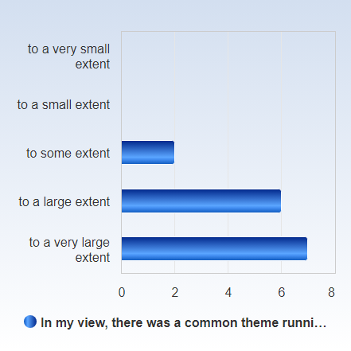

 | Mean | Standard Deviation | Coefficient of Variation | Min | Lower Quartile | Median | Upper Quartile | Max
In my view, there was a common theme running throughout the course – from learning outcomes to examinations. | 4,3 | 0,7 | 16,7 % | 3,0 | 4,0 | 4,0 | 5,0 | 5,0

In my view, the course has promoted a scientific way of thinking and reasoning (e.g. analytical and critical thinking, independent search for and evaluation of information).
In my view, the course has promoted a scientific way of thinking and reasoning (e.g. analytical and critical thinking, independent search for and evaluation of information). Number of responses  to a very small extent 0 (0,0%)  to a small extent 0 (0,0%)  to some extent 2 (13,3%)  to a large extent 5 (33,3%)  to a very large extent 8 (53,3%)  Total 15 (100,0%) | 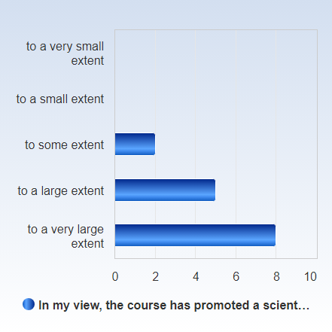

 | Mean | Standard Deviation | Coefficient of Variation | Min | Lower Quartile | Median | Upper Quartile | Max
In my view, the course has promoted a scientific way of thinking and reasoning (e.g. analytical and critical thinking, independent search for and evaluation of information). | 4,4 | 0,7 | 16,7 % | 3,0 | 4,0 | 5,0 | 5,0 | 5,0

In my view, during the course, the teachers have been open to ideas and opinions about the course’s structure and content.
In my view, during the course, the teachers have been open to ideas and opinions about the course’s structure and content. Number of responses  to a very small extent 0 (0,0%)  to a small extent 0 (0,0%)  to some extent 0 (0,0%)  to a large extent 6 (40,0%)  to a very large extent 9 (60,0%)  Total 15 (100,0%) | 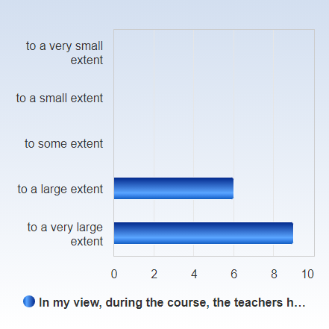

 | Mean | Standard Deviation | Coefficient of Variation | Min | Lower Quartile | Median | Upper Quartile | Max
In my view, during the course, the teachers have been open to ideas and opinions about the course’s structure and content. | 4,6 | 0,5 | 11,0 % | 4,0 | 4,0 | 5,0 | 5,0 | 5,0

The course's pedagogic structure has stimulated my learning.
The course's pedagogic structure has stimulated my learning. Number of responses  to a very small extent 0 (0,0%)  to a small extent 0 (0,0%)  to some extent 3 (20,0%)  to a large extent 7 (46,7%)  to a very large extent 5 (33,3%)  Total 15 (100,0%) | 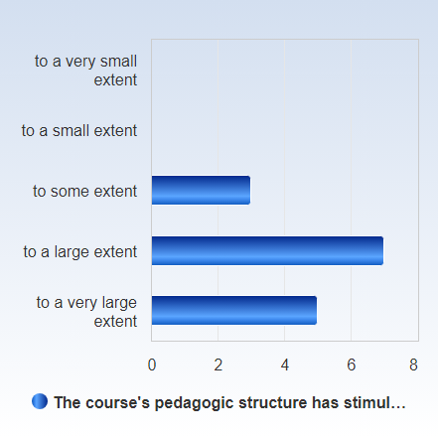

 | Mean | Standard Deviation | Coefficient of Variation | Min | Lower Quartile | Median | Upper Quartile | Max
The course's pedagogic structure has stimulated my learning. | 4,1 | 0,7 | 18,0 % | 3,0 | 4,0 | 4,0 | 5,0 | 5,0

My prior knowledge and competence were sufficient to succeed in this course.
My prior knowledge and competence were sufficient to succeed in this course. Number of responses  to a very small extent 0 (0,0%)  to a small extent 1 (6,7%)  to some extent 3 (20,0%)  to a large extent 7 (46,7%)  to a very large extent 4 (26,7%)  Total 15 (100,0%) | 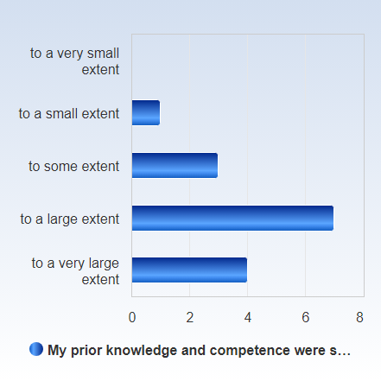

 | Mean | Standard Deviation | Coefficient of Variation | Min | Lower Quartile | Median | Upper Quartile | Max
My prior knowledge and competence were sufficient to succeed in this course. | 3,9 | 0,9 | 22,5 % | 2,0 | 3,5 | 4,0 | 4,5 | 5,0

The feedback I received impacted my learning.
The feedback I received impacted my learning. Number of responses  to a very small extent 0 (0,0%)  to a small extent 0 (0,0%)  to some extent 3 (20,0%)  to a large extent 8 (53,3%)  to a very large extent 4 (26,7%)  Total 15 (100,0%) | 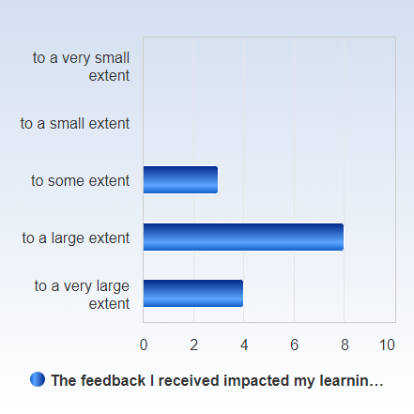

 | Mean | Standard Deviation | Coefficient of Variation | Min | Lower Quartile | Median | Upper Quartile | Max
The feedback I received impacted my learning. | 4,1 | 0,7 | 17,3 % | 3,0 | 4,0 | 4,0 | 4,5 | 5,0

The course increased my understanding of an ethical approach in the caring sciences.
The course increased my understanding of an ethical approach in the caring sciences. Number of responses  to a very small extent 0 (0,0%)  to a small extent 0 (0,0%)  to some extent 3 (20,0%)  to a large extent 4 (26,7%)  to a very large extent 8 (53,3%)  Total 15 (100,0%) | 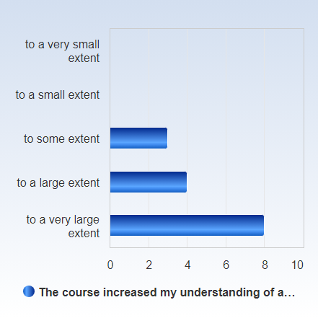

 | Mean | Standard Deviation | Coefficient of Variation | Min | Lower Quartile | Median | Upper Quartile | Max
The course increased my understanding of an ethical approach in the caring sciences. | 4,3 | 0,8 | 18,8 % | 3,0 | 4,0 | 5,0 | 5,0 | 5,0

The course expectations of me as a student were clear.
The course expectations of me as a student were clear. Number of responses  to a very small extent 0 (0,0%)  to a small extent 0 (0,0%)  to some extent 2 (13,3%)  to a large extent 5 (33,3%)  to a very large extent 8 (53,3%)  Total 15 (100,0%) | 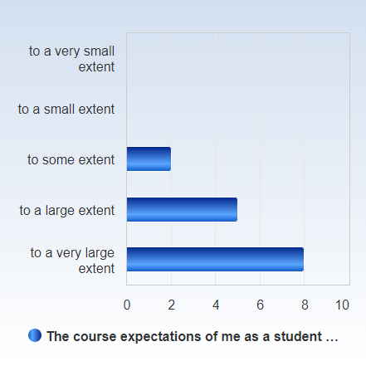

 | Mean | Standard Deviation | Coefficient of Variation | Min | Lower Quartile | Median | Upper Quartile | Max
The course expectations of me as a student were clear. | 4,4 | 0,7 | 16,7 % | 3,0 | 4,0 | 5,0 | 5,0 | 5,0

It was easy to find the information I needed in Canvas.
It was easy to find the information I needed in Canvas. Number of responses  to a very small extent 0 (0,0%)  to a small extent 0 (0,0%)  to some extent 0 (0,0%)  to a large extent 3 (20,0%)  to a very large extent 12 (80,0%)  Total 15 (100,0%) | 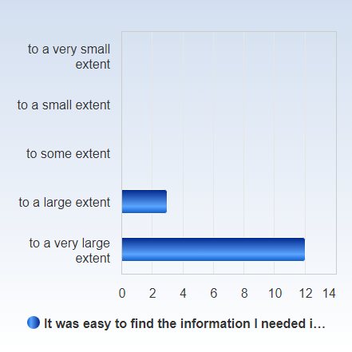

 | Mean | Standard Deviation | Coefficient of Variation | Min | Lower Quartile | Median | Upper Quartile | Max
It was easy to find the information I needed in Canvas. | 4,8 | 0,4 | 8,6 % | 4,0 | 5,0 | 5,0 | 5,0 | 5,0

